Firewood Sydney- What You Should Know Before You Buy
Buying firewood is as easy as following some basic tips. To help you get the best value for your money, we have put together a few tips to get you there:
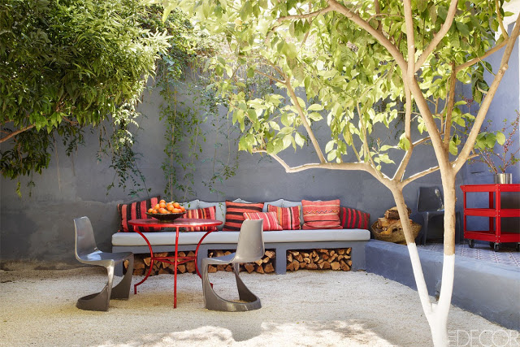
1. Not all hardwoods give good fire
Most experts recognize that hardwood is usually better. The most common hardwood tends to be oak. However, not all oaks are created the same way. In fact, white oak does not provide the same burning effect as oak and other hardwoods, so extra effort is needed. For this reason, do not use this type of tree to buy, or at least make it as small as possible from every purchase.
2. At times softwood is better
Traditional wisdom suggests that hardwood is better than softwood, but that is not always the case. If you have limited time to search for firewood suppliers near me, remember that conifers are actually better because it takes less time to dry. Conifers are also the best purchase for people who only occasionally burn wood. That is because they come at a cheaper price. In these cases, the most expensive hardwood money is wasted.
3. Purchase in bulk if possible
Fires usually last a year on hard trees every season, so it is worth buying them in bulk. Depending on the size, not only will you have access to buy firewood Sydney, but also there may be a discount for the price. For this reason, you need to purchase a large number of trees and make sure that the wood storage or shelves can be moved in bulk. These steps increase the chance of achieving high quality when you need it.
4. Get the best tools to help you create seasoned firewood
If you do not have the tools to tag the tree, taking many steps to acquire a quality fire can defeat itself. Serious fire buyers must purchase shelves and shelves from fire covers. These are very important for drying the tree and protecting it from strong elements. This gives dry wood free of mold and mold growth.
The fire has been a source of comfort and warmth to humans for thousands of years. However, because there are so many heating options available, burning wood for heating provides comfort for people without other heat sources. For some people, they have resources to produce themselves, but for most, they have to buy them.
Firewood is usually sold with 128 cubic feet of tightly stacked yarn. When purchasing yarn, make sure that at least 128 cubic feet add dimensions.
Some people sell timber with a cladding or interior thread, but the problem with these measurements is not measuring the size of the tree. Instead, only the length and height of the stack are reported, regardless of the depth. If the parts are short, the cover is smaller than the tree if the parts are long.
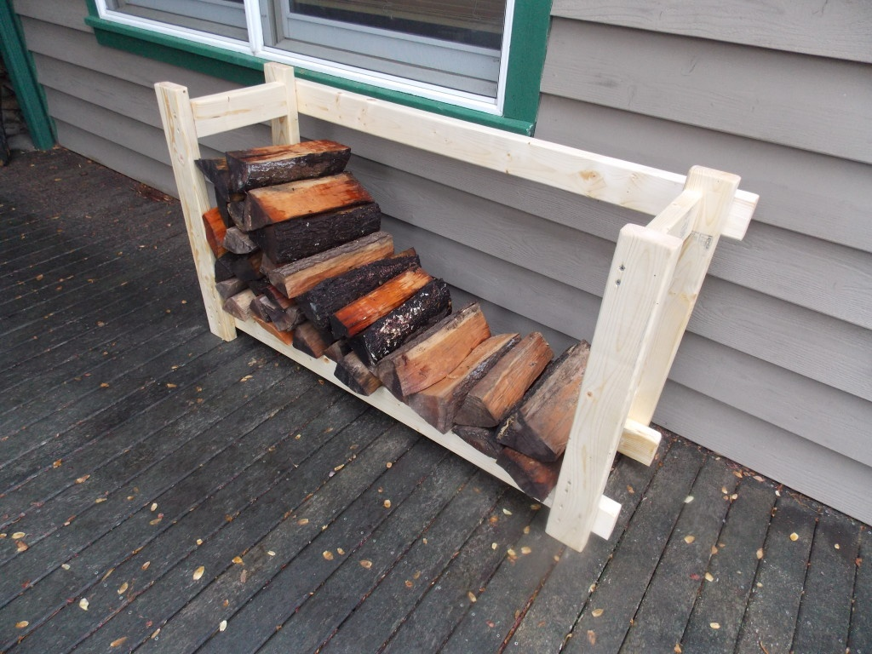
Another common complaint I hear is about how someone sells it to a dry tree, but it ends up being green or wet. There are ways to determine if the tree is green or dry, but it can be difficult for unskilled eyes. One way to increase the probability of getting what you need is to use a reputable and recommended dealer. However, the best way to know if you have dry wood is to buy it early before using it. This way you can get a tree when the tree is still green. You can also get the lowest-cost wood per year and dry it yourself. When you buy it from six months to a year before you need it, you will know that you have a dry tree and you do not need to contact someone at the last minute.

