Let The Carpenter Give Your Home A New Identity

Festivals are just around the corner and you must have a plethora of things to take care of for the same. The most important thing to grapple with is your home décor. Redecorating your home could be difficult if you don’t have the right resources and the required skills for it. A skill like carpentry is something that you would need to rope into in order to make your home look amazingly perfect to awestrike your guests. Even if you are not a professional carpenter, there are some skills that you might learn of your own to do the decoration you require.

There Are Several Skills Or Traits Of A Carpenter Mentioned Below That You Should Know If You Really Want To Pull Off A Perfect Décor:

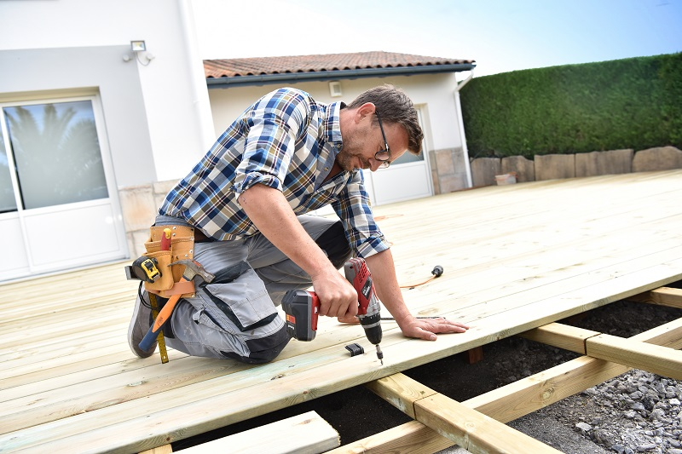

Calculations And Measurements:

If you are bad at calculation or measurement or you don’t like doing so, you probably won’t be able to pull it off. Carpenter has to work on a very small scale and needs to make sure that all the dimensions, gaps, and shapes are perfect. Even a single mistake can change an entire design which is not acceptable in a professional scenario. There will be times when you will have to apply proper mathematics to your work. For instance, you may have to change the scale of a drawing and then start to build its form. You may have to change the dimensions according to the availability of space, material, etc. You first need to understand your requirement. And the modification of your home. You should decide if the windows, partitions, doors also need modification.
There are carpenters who work only on cabinets and some work on windows, doors. So have a plan ready before hiring the carpenters. If it is a large project, ensure the architect has a plan ready before you hire the carpenter.

Strength And Energy:

Carpentry is no 9-5 job where you will have to sit back and work for the whole day. You will have to work both indoor or outdoor. No matter how hot or cold it is outside, you will have to step outside under the sky and get going with the work. You will have to lift up instruments, wood pieces and other instruments of your own. Even if you are a woman, you can expect a lot of heavy lifting in this trade. There will be times when you will have to stoop down and work like that for a long duration. Becoming a carpenter involves climbing up spaces, scaffoldings to fix things up or remove them away. All this hardship of the trade calls for a lot of stamina without which you won’t be able to survive this job.

Sharp Mechanical Skills:

To work as a carpenter, you are required to combine your knowledge with your practical work so that you can carve out your design properly. Your hand and mind should be in tandem and the coordination between the two should get better every day. Your command over your machines should be perfect so that you are able to give the wood a required shape. Make sure to learn to use all the tools such as chisels, axes, custom doors in your instruction classes. Above all, steadier your hands are, better would be your precision and measurements.

Communication And Marketing:



Last but not the least, you have to redecorate your home but not give away all your money. The way you would bargain over the price of the material and convince vendors to agree on your terms is going to decide how cheap or good quality materials you will get. The better your communication skills are, the better raw materials you would be able to get that too at a much lower price.

Carpentry is an art that most people do not understand. The way you mold a piece of wood and give it a totally different face is what carpentry truly is all about. It’s totally on you as to how you use these skills and give your home a totally different look. Make the most out of your home as a carpenter by working on the skills mentioned above in the article.

